**Total No. of Questions : 8 Roll No.....................................**

**BT- 105**

**B.Tech II Semester**

**PUT June 2022**

**ENGINEERING GRAPHICS**

**BRANCH: AIML, CE**

**Time : Three hours**

**Maximum Marks: 70**

**Note: i. Attempt any Five questions.**

**ii. All question carry equal marks.**

**Q1)** A rectangular plot of 16 square kilometers in area is represented on a certain map by a similar rectangle of area 1 square centimeters. Draw a plain scale to show units of ten and single km and long enough to read up to 60 km. Find the R.F. of the scale Also show distance of 53 km on it.

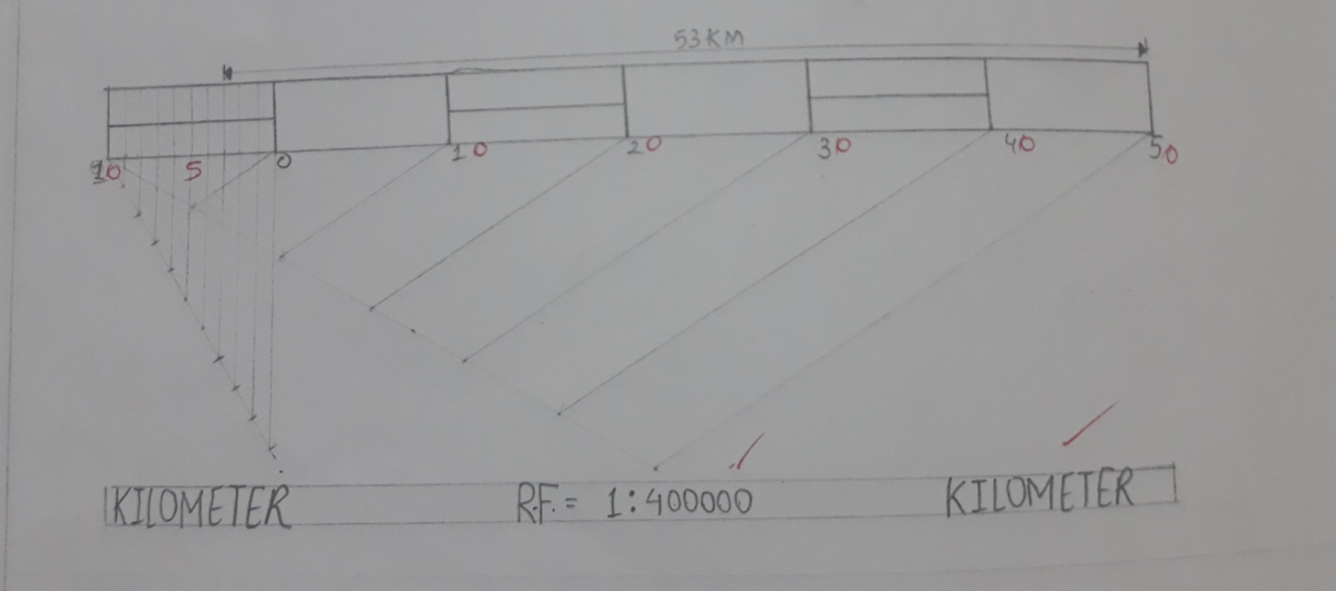

b) A circle of 5 cm diameter is rolling on a straight line without slipping. Draw the locus of a point on the circle and name the curve.

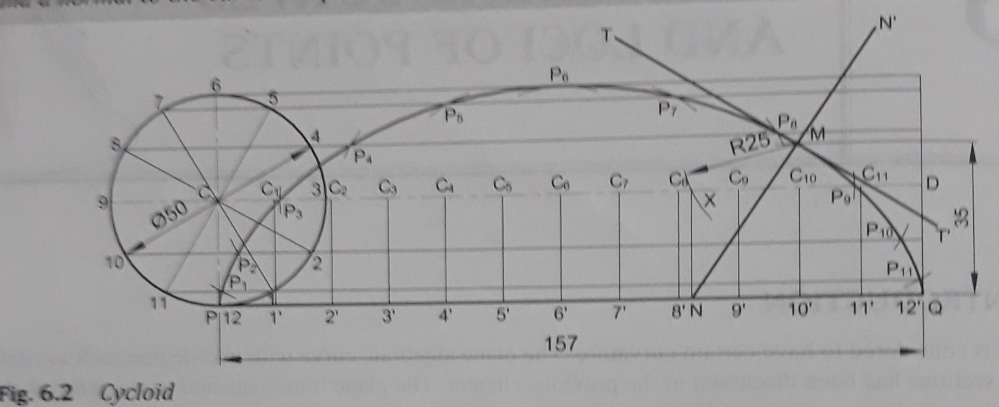

**Q)2** Draw the projections of the following points on a common reference line keeping distance between projectors 30mm apart.

(i)Point A is 10mm above the H.P. and 25mm in front of V.P.

(ii) Point B is in the V.P. and 10mm above the H.P.

(iii) Point C is 20mm above the H.P. and 15mm behind of V.P.

(iv) Point D is in the H.P. and is 10mm in front of V.P.

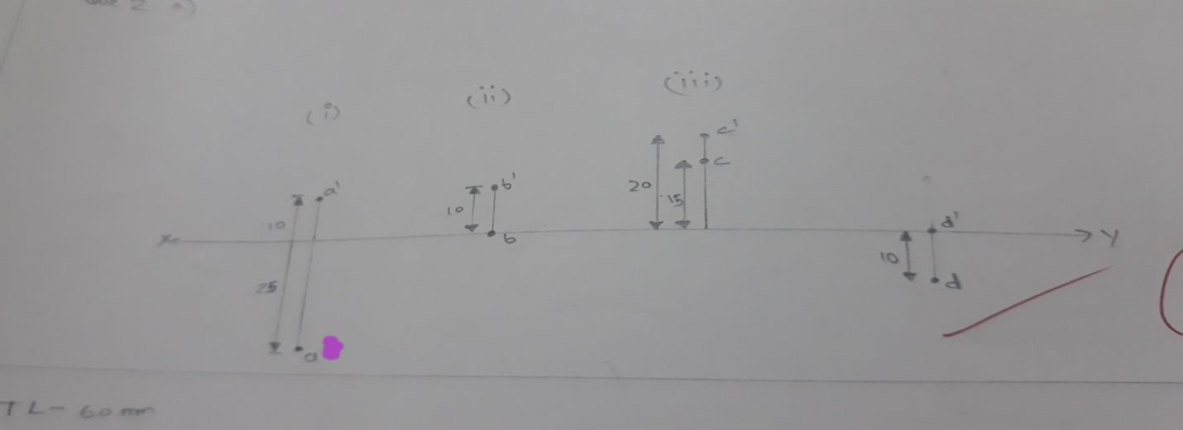

b) Draw the projection of a line AB, whose end A is in HP and 10 mm in front of VP. The line makes an angle of 30° with VP and 40° with HP. The line is 60 mm long.

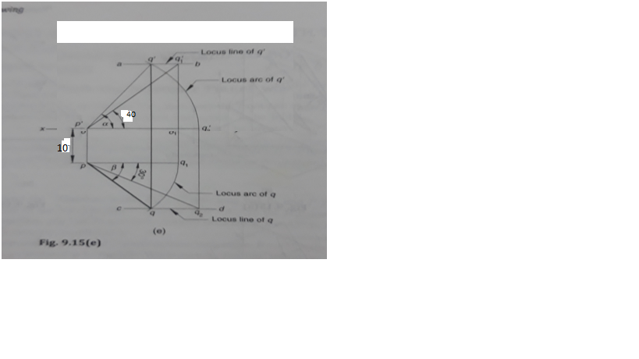

**Q3)** A regular hexagon of 30mm side has a corner in the H.P. It’s surface is inclined at 450 to the H.P. and top view of the diagonal through the corner which is in the H.P. makes an angle of 600 with the V.P. Draw it’s projection.

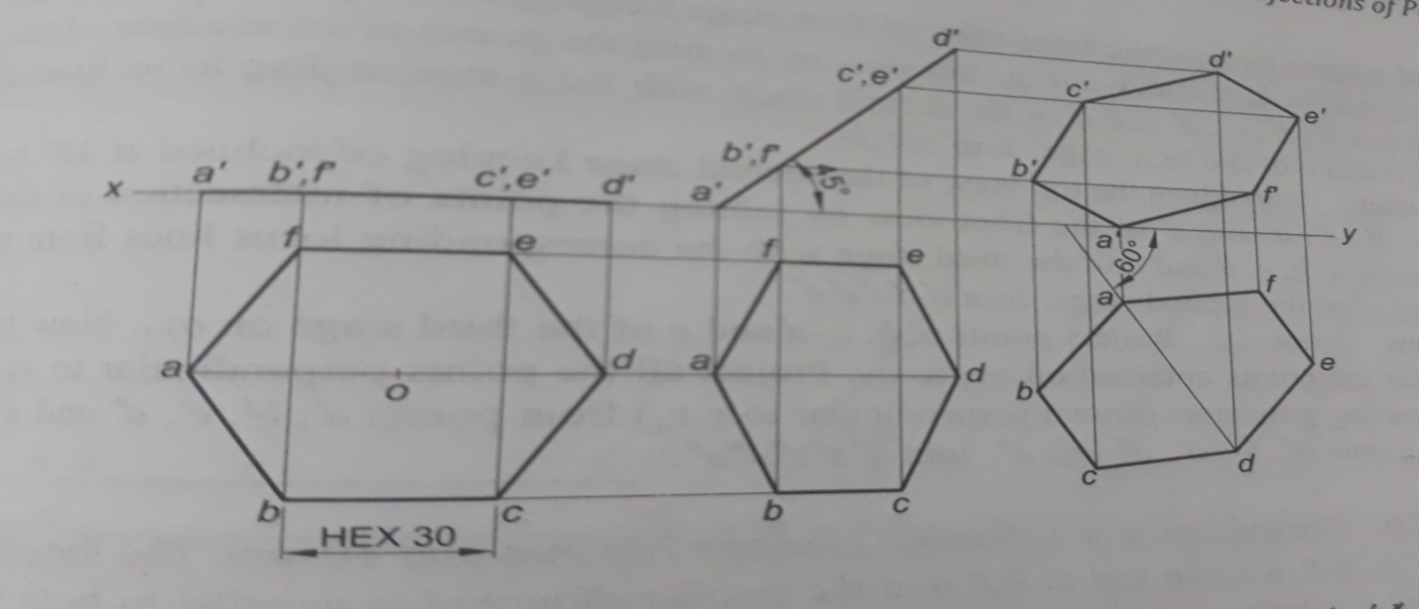

**Q4)** A right hexagonal prism edge of base 30mm and height 60mm is resting on one of it’s base edges in HP and inclined at 400 to the HP. Draw the projections of the solid.

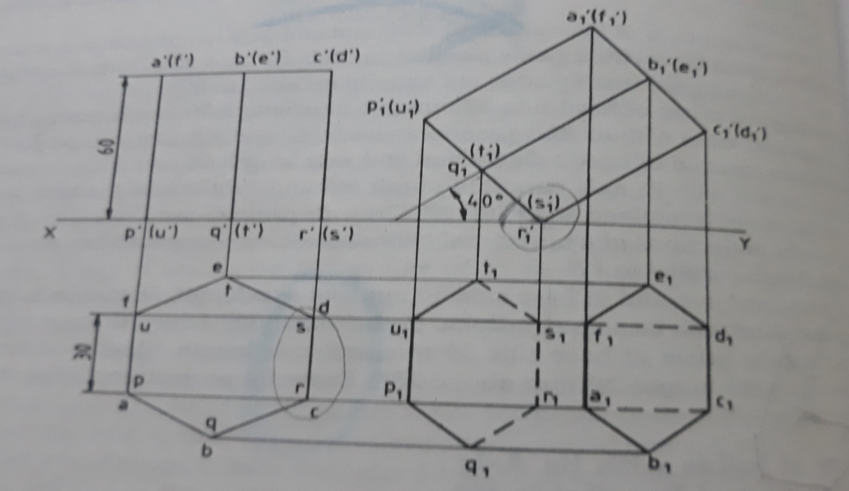

**Q 5)** A pentagonal pyramid of base 30 mm and axis 60 mm long, has its base

resting on HP such that base edge towards the VP is parallel to it. A section plane perpendicular to the HP and inclined at 45° to VP cuts the pyramid at a distance 20 mm from the axis. Draw its top view, sectional front view and development of lateral surface.

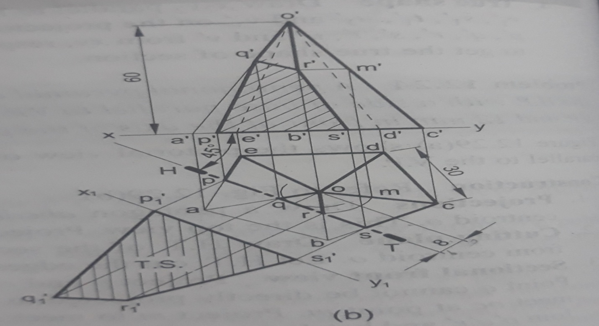

**Q6)** Draw an isometric view of the frustum of a cone with lower base diameter 50 mm and top base 30mm and height of frustum is 40 mm.  
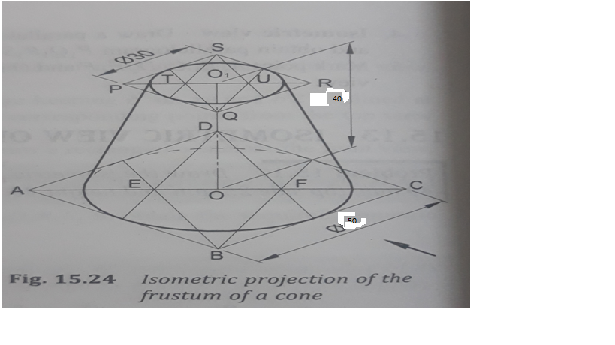

**Q7)** a)What are the advantages of using CAD?

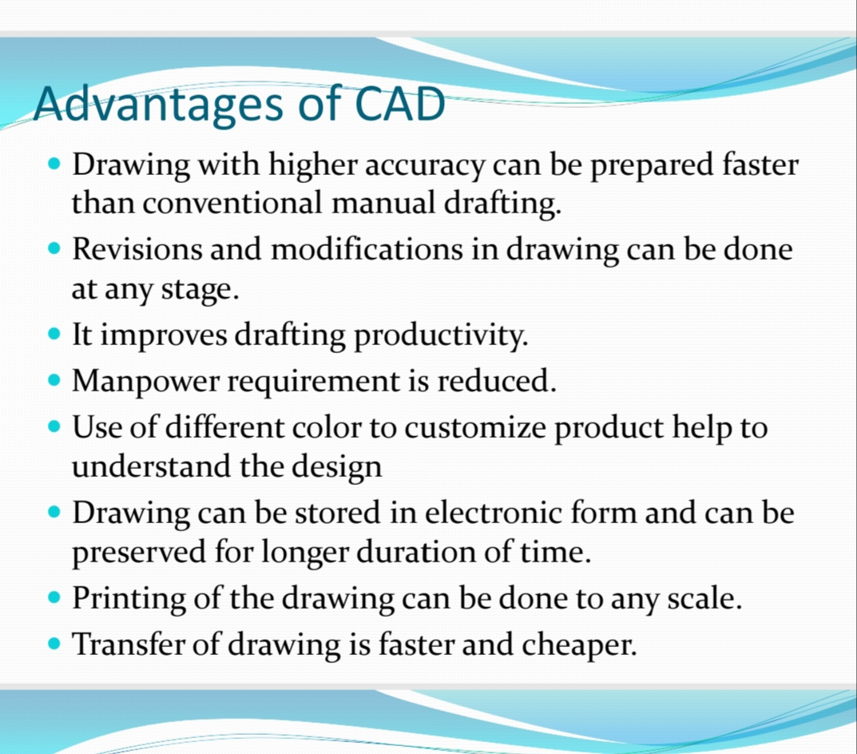

b) Explain the co-ordinate system used in CAD.

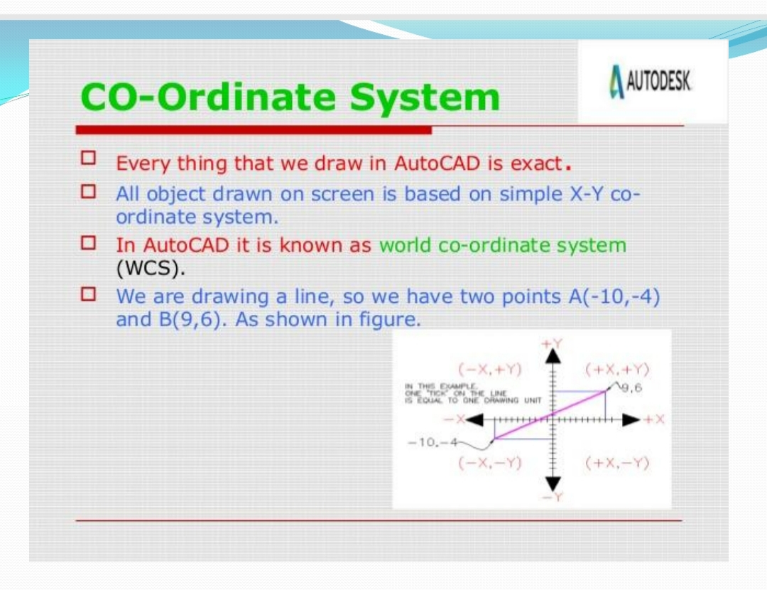

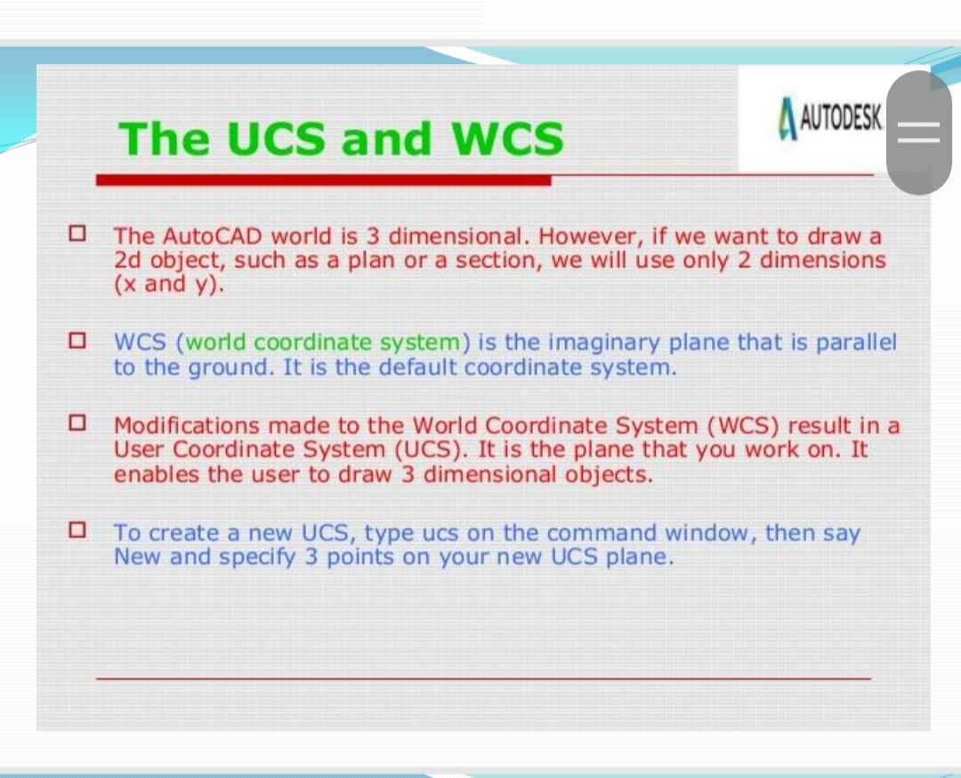

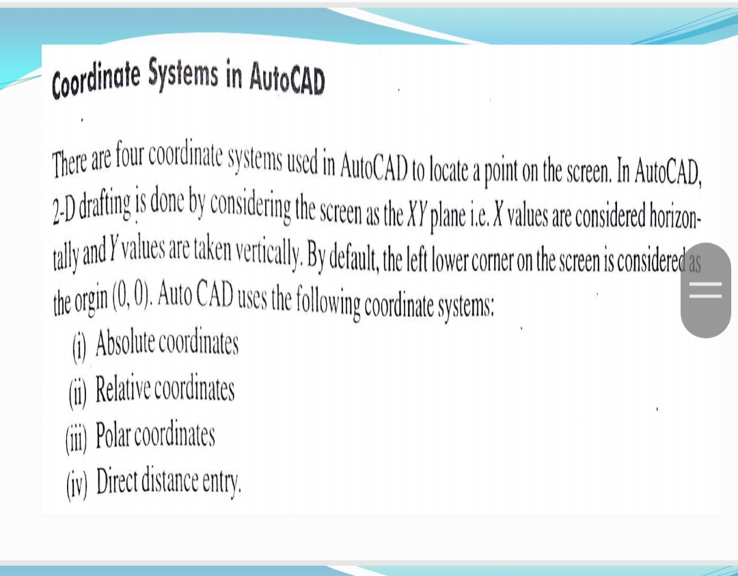

**Q8)** Write short note on the following.

a) Editing commands in CAD. b) Types of projection

c) Tool bar d) 2D and 3D model

